**Install bootstrap command**

npm install ngx-bootstrap –save

**index.html**

<!doctype html>

<html lang="en">

<head>

<meta charset="utf-8">

<title>MyApp</title>

<base href="/">

<meta name="viewport" content="width=device-width, initial-scale=1">

<link rel="icon" type="image/x-icon" href="favicon.ico">

<link href="https://maxcdn.bootstrapcdn.com/bootstrap/3.3.7/css/bootstrap.min.css" rel="stylesheet">

</head>

<body>

<app-root></app-root>

</body>

</html>

**App.component.ts**

import { Component } from '@angular/core';

@Component({

selector: 'app-root',

templateUrl: './app.component.html',

styleUrls: ['./app.component.css']

})

export class AppComponent {

title = 'my-app';

}

**App.component.html**

<!--The content below is only a placeholder and can be replaced.-->

<div style="text-align:center">

<h1 style="text-align: left ">

<!-- {{ title }}! -->

</h1>

<app-menu></app-menu>

<br>

<hr>

<router-outlet></router-outlet>

</div>

**Weather component folder files**

**Weather.component.ts**

import { Component, OnInit } from '@angular/core';

import {SharedService } from '../Shared//Shared.Service'

@Component({

selector: 'app-weather',

templateUrl: './weather.component.html',

styleUrls: ['./weather.component.css']

})

export class WeatherComponent implements OnInit {

data:any;

public txtWeather: string='TamilNadu';

constructor(private sharedservie: SharedService) {

}

ngOnInit() {

// this.sharedservie.getWeather(this.txtWeather.toString()).subscribe(res=>

// {

// this.data = res;

// });

}

public GetWeatherInfo(){

this.sharedservie.getWeather(this.txtWeather.toString()).subscribe(res=>

{

this.data = res;

});

}

}

**Weather.component.html**

<div class="weather">Yahoo! Weather</div>

<form>

<div class="row">

<div class="col-sm-1" >&nbsp;</div>

<div class="col-sm-2"><label for="city">Enter City Name</label></div>

<div class="col-sm-3">

<input type="text" name="city" class="form-control" [(ngModel)]="txtWeather"/></div>

<div class="col-sm-6" >&nbsp;</div>

</div>

<div class="row">

<div class="col-sm-3" >&nbsp;</div>

<div class="col-sm-3" >

<button type="button" class="btn btn-primary" (click)="GetWeatherInfo()" >Submit</button></div>

</div>

</form>

<div class="row"> <div class="col-sm-1" >&nbsp;</div>

<div class="col-sm-2">

<div>

<i><b>City, Country : </b></i><span *ngIf="data!=null">{{data.query.results.channel.location.city}} &nbsp; {{data.query.results.channel.location.country}}</span></div>

<div><i><b>Current Condition : </b></i><span *ngIf="data!=null">{{data.query.results.channel.item.condition.text}}</span></div>

<div><i><b>Current Temperature : </b></i><span *ngIf="data!=null">{{data.query.results.channel.item.condition.temp}}</span></div>

</div>

</div>

**Weather.component.css**

.weather{

font-size:50px;

}

.btn

{

margin-top:10px;

}

**Currency component folder files**

**Currency.component.ts**

import { Component, OnInit } from '@angular/core';

import {SharedService} from '../Shared/Shared.Service'

@Component({

selector: 'app-currency',

templateUrl: './currency.component.html',

styleUrls: ['./currency.component.css']

})

export class CurrencyComponent implements OnInit {

data:any;

public txtCurrency: string='USD';

constructor(private sharedservice: SharedService) {

}

ngOnInit() {

// this.sharedservice.getCurrency('USD').subscribe(res=>

// {

// this.data = res;

// });

}

public getCurrencyInfor(){

this.sharedservice.getCurrency(this.txtCurrency.toString()).subscribe(res=>

{

this.data = res;

});

}

}

**Currency.component.css**

.currency

{

font-size:50px;

}

.btn

{

margin-top:10px;

}

**Currency.component.html**

<div class="currency">Currency Details!</div>

<form>

<div class="row">

<div class="col-sm-1" >&nbsp;</div>

<div class="col-sm-2"><label for="USD">Enter Currency</label></div>

<div class="col-sm-3">

<input type="text" name="USD" class="form-control" [(ngModel)]="currency"/></div>

<div class="col-sm-6" >&nbsp;</div>

</div>

<div class="row">

<div class="col-sm-3" >&nbsp;</div>

<div class="col-sm-3" >

<button type="button" class="btn btn-primary" (click)="getCurrencyInfor()" >Submit</button></div>

</div>

</form>

<div class="row"> <div class="col-sm-1" >&nbsp;</div>

<div class="col-sm-2">

<div>

<i><b>Success : </b></i><span *ngIf="data!=null">{{data.success}}</span></div>

<div><i><b>Error : </b></i><span *ngIf="data!=null">{{data.error.info}}</span></div>

</div>

</div>

**Movie component folder files**

**Movie.component.ts**

import { Component, OnInit } from '@angular/core';

import { SharedService } from '../Shared/Shared.Service';

import { fn } from '@angular/compiler/src/output/output_ast';

@Component({

selector: 'app-movie',

templateUrl: './movie.component.html',

styleUrls: ['./movie.component.css']

})

export class MovieComponent implements OnInit {

data: any;

public txtInput: string='thor';

constructor(private sharedservice: SharedService) { }

ngOnInit() {

// this.sharedservice.getMovie('thor').subscribe(res => {

// this.data = res;

// });

}

public getData(){

this.sharedservice.getMovie(this.txtInput.toString()).subscribe(res => {

this.data = res;

});

// this.sharedservice.getMovie('thor').subscribe(res => {

// alert(this.txtInput);

// this.data = res;

// });

}

}

**Movie.component.css**

.movie{

font-size:50px;

}

.btn

{

margin-top:10px;

}

**Movie.component.html**

<div class="movie">Movie Details!</div>

<form>

<div class="row">

<div class="col-sm-1" >&nbsp;</div>

<div class="col-sm-2"><label for="movie">Enter Movie Name</label></div>

<div class="col-sm-3">

<input type="text" name="movie" class="form-control" [(ngModel)]="txtInput"/></div>

<div class="col-sm-6" >&nbsp;</div>

</div>

<div class="row">

<div class="col-sm-3" >&nbsp;</div>

<div class="col-sm-3" >

<button type="button" class="btn btn-primary" (click)="getData()" >Submit</button></div>

</div>

</form>

<div class="row"> <div class="col-sm-1" >&nbsp;</div>

<div class="col-sm-2">

<div>

<i><b>Title, Year :</b></i><span *ngIf="data!=null">{{data.Title}} &nbsp; {{data.Year}}</span></div>

<div><i><b>Director:</b></i><span *ngIf="data!=null">{{data.Director}}</span></div>

<div><i><b>Actors :</b></i><span *ngIf="data!=null">{{data.Actors}}</span></div>

</div>

</div>

**Output screens**

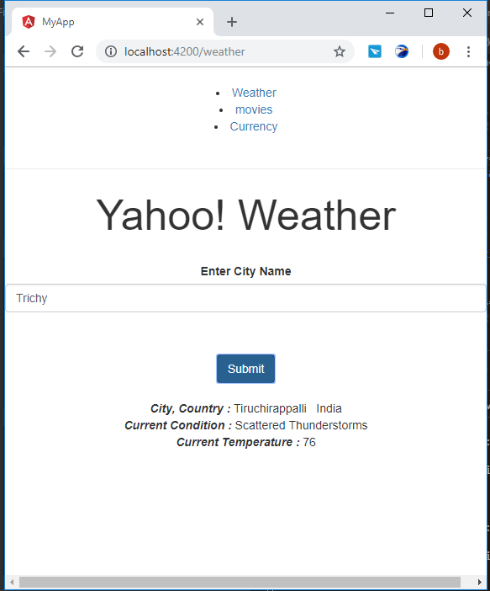

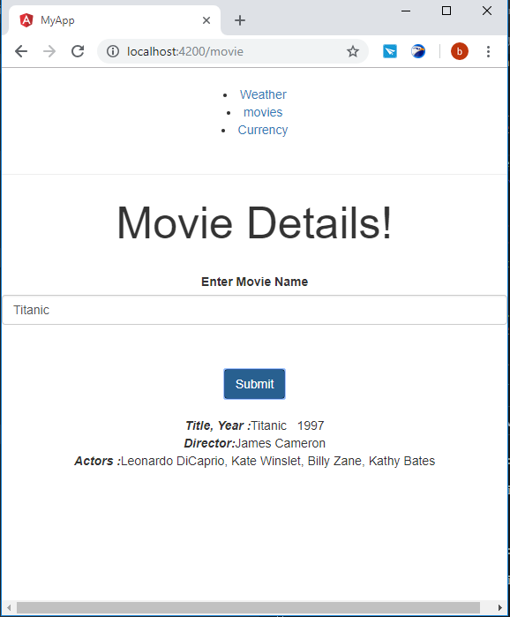

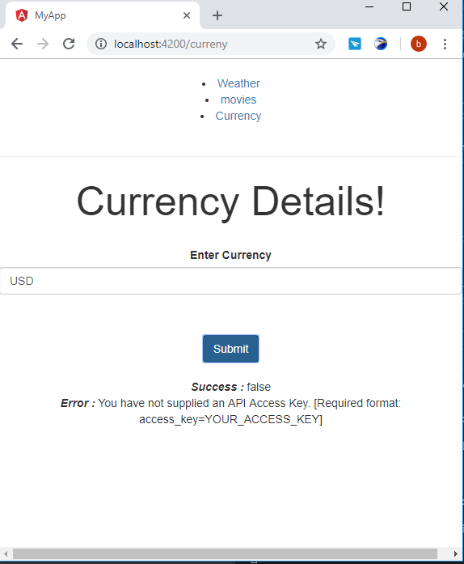

**Due to given API Deprecated and need to create for that on my own, so its not possible to create it.**

**So getting reponse like above.**